

What is a safety disclaimer?

Safety Disclaimer is a safety statement made on all parts of the business to include:

-social media
-In the app
-App Store
- Website

Why?

We provide a directory of warmlines. We need to protect our business from getting sued. Additionally, and more importantly, we need to make sure that our customers who are needing a higher level of mental health care are calling the cops or a crisis center.

Our Statement:

BetterCalls is a national warmline directory for phone support and wellness. We are not a crisis or emergency line. If you are in a crisis, please call 911. If you are in a mental health crisis, you can call 988 or your state mental health crisis line.

Where does the statement go?

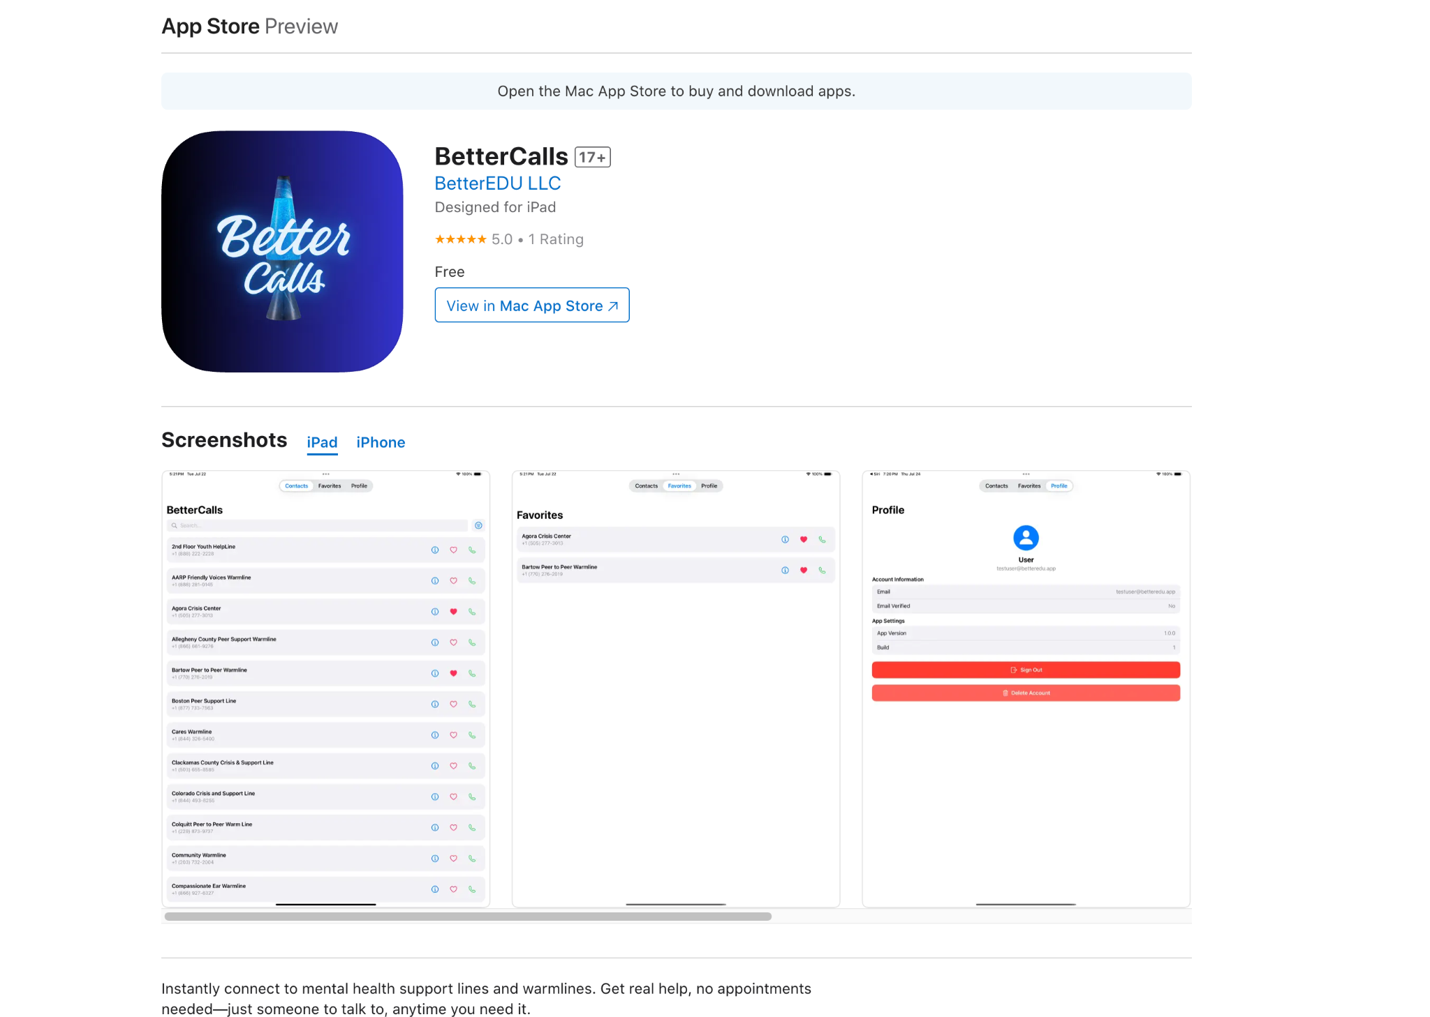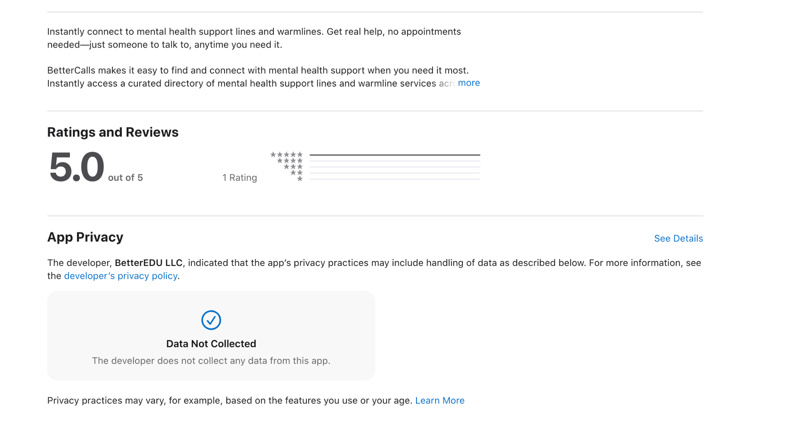

Also in the app

